- PUBLIC SAFETY NOTICE -

Town of Meridian Hills
January 24, 2014

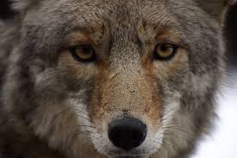

Dear Neighbors,

A resident's dog in the 7200 block of Washington Blvd was attacked by three coyotes on Wednesday afternoon at 2:30pm. The dog required three hours of surgery and is lucky to be alive.

The veterinarian indicated that this type of behavior is very rare, as coyotes typically attack in the cover of darkness. The nature of this attack is undoubtedly caused by the severe weather we've been experiencing over the past month and a lack of food for the coyotes.

With Marott Park, Holliday Park, Meridian Hills Country Club and the river adjacent to our town, it's not unusual to see coyotes. If you encounter one, let it know that it has been seen by waving your arms and stamping your feet. Place yourself between it and children, especially younger ones who don't know how to react to a wild animal. Make loud noises or throw rocks at it. Never turn your back on a coyote, and never attempt to feed or befriend a coyote. They are wild animals - not pets - and should be treated as such.

Please be sure to share this information with your neighbors, keep an eye on all pets, and keep small pets on a leash when letting them outside. Lastly, call 9-1-1 if there is an emergency and you need immediate assistance.

Stay Warm!

Terry O'Brien
Town of Meridian Hills

